PERSONALIZED E-LEARNING COURSE RECOMMENDATION SYSTEM
Design and Implementation
Department of Computer Science and Engineering, [COLLEGE NAME]
Batch C7 (CSE-C) · Academic year [ACADEMIC YEAR]
Table 1: Project team
S.No. | Student name | Roll number
1 | PITTALA AKHILA | 23K91A05J3
2 | MUNDALA SANDHYA | 23K91A05G5
3 | MULA THANUJ REDDY | 23K91A05G4
4 | MAJJIGAPU JAGADESHWAR REDDY | 23K91A05E1

Project guide: K GAYATHRI
Chapter and section numbers quoted in the text (for example Section 6.6 or Chapter 8) refer to the full project report, 17.Final Document. Figures and tables in this document are numbered from 1.

1. DESIGN

5.1 Architecture
The design follows two rules: keep each tier replaceable, and keep the recommendation logic in one module that the routes only call. The original Jinja2 interface and the React interface use the same FastAPI routes and the same database, so the two front ends always agree.
Table 2: The four tiers
Tier | Components | Responsibility
Presentation | React 19 SPA (port 5407); Jinja2 pages (port 8407) | Collect input, show ranked courses, explanations and model transparency
Application | FastAPI routes, Pydantic validation, token authentication | Validate requests, resolve the learner, orchestrate ranking, log feedback
Recommendation | TF-IDF, rule-based terms, logistic-regression success model, uplift models | Score and rank the catalogue
Data | SQLite file, JSON catalogue, joblib artefacts | Persist accounts, events and logs; hold the trained models

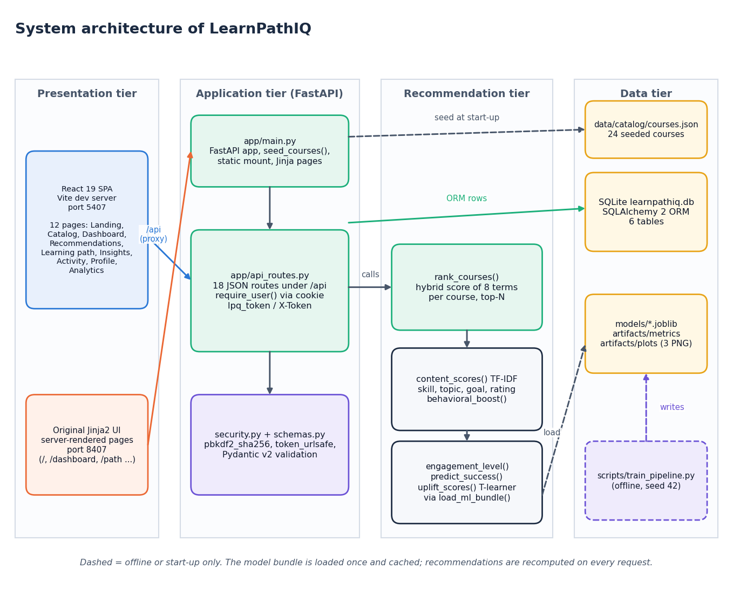
Figure 1: System architecture of LearnPathIQ
The system has four tiers. In the presentation tier the React 19 single-page application (Vite development server, port 5407) and the original server-rendered Jinja2 interface (port 8407) are the two ways a learner reaches the system; the React server proxies /api and /static to the backend so the session cookie stays same-origin. The application tier is the FastAPI service: app/main.py creates the application, seeds the course table, mounts the static folder and serves the Jinja pages, while app/api_routes.py holds the 18 JSON routes under /api and resolves the learner from the lpq_token cookie or the X-Token header; security.py and schemas.py supply password hashing, token generation and request validation. The recommendation tier is app/recommender.py: rank_courses() combines the TF-IDF, skill, topic, goal, rating and behaviour terms with the engagement score, the predicted success probability and the per-action uplift, and the model bundle is read once through load_ml_bundle(). The data tier holds the SQLite file learnpathiq.db (six tables), the 24-course catalogue in data/catalog/courses.json that seeds the course table at start-up, and the trained artefacts (models/*.joblib, artifacts/metrics, artifacts/plots), which the offline script scripts/train_pipeline.py writes. Dashed arrows are start-up or offline only.

5.2 High-level workflow
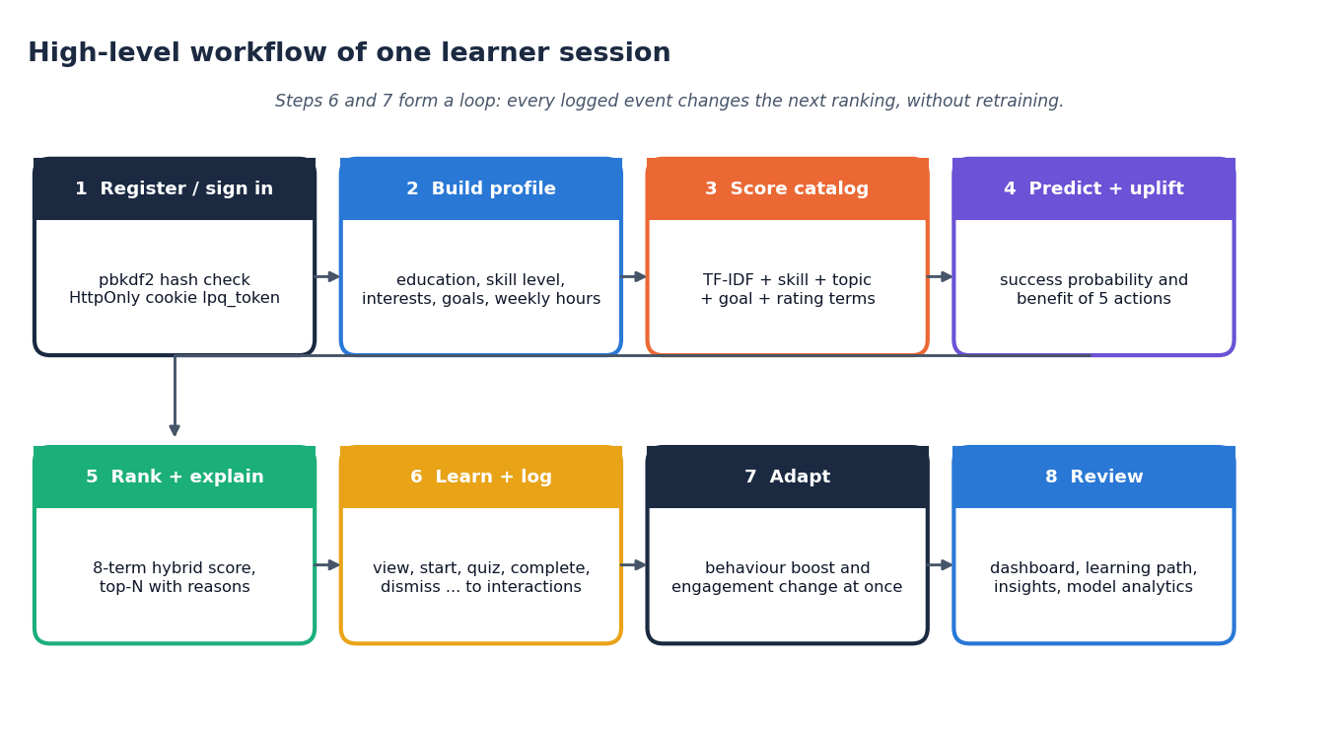
Figure 2: High-level workflow of one learner session
A session has eight steps. The learner registers or signs in (the password is checked against its PBKDF2 hash and an HttpOnly cookie is set), builds a profile (education, skill level, interests, preferred topics, goals, weekly hours), and the system scores the catalogue against it. The learner state is then fed to the success model and the action-benefit models, the eight terms are combined into a ranked list with a short explanation per course, and the learner acts on it (view, start, quiz, complete, dismiss and so on), each action being written to the interactions table. Because the behaviour and engagement terms are recomputed from that table on every request, the next ranking changes at once without retraining; the dashboard, learning path, insights and model analytics screens present the result. Steps 6 and 7 form the feedback loop.

5.3 Data flow diagrams

Level 0
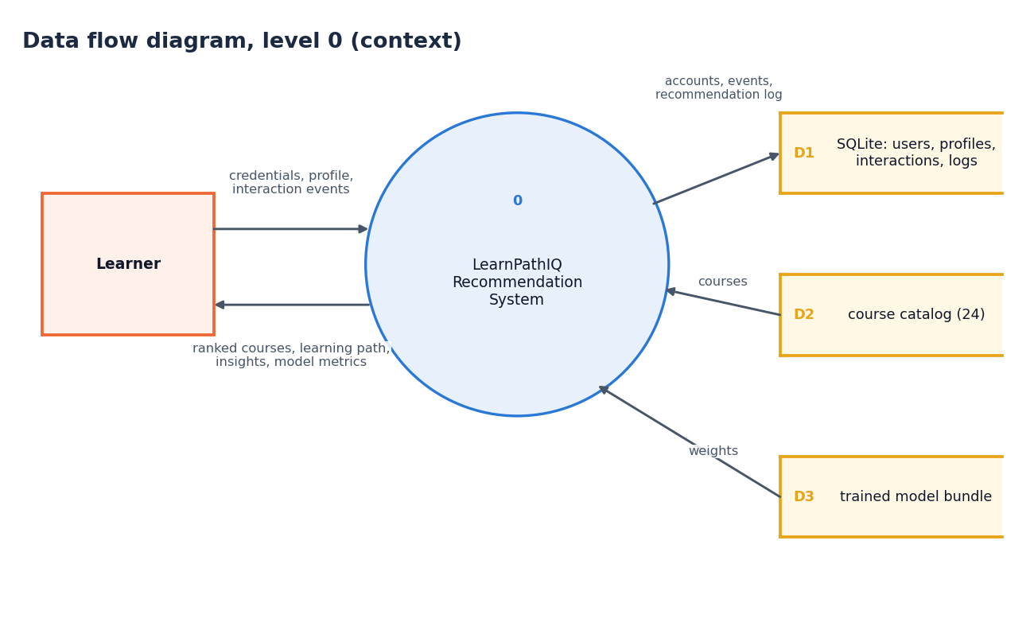
Figure 3: Data flow diagram, level 0 (context diagram)
The context diagram shows LearnPathIQ as a single process with one external entity, the learner. The learner sends credentials, profile data and interaction events; the system returns ranked courses, the learning path, insights and model metrics. Internally the process reads and writes the SQLite store (D1: users, profiles, interactions and the recommendation log), reads the course catalogue (D2) and reads the trained model bundle (D3).

Level 1
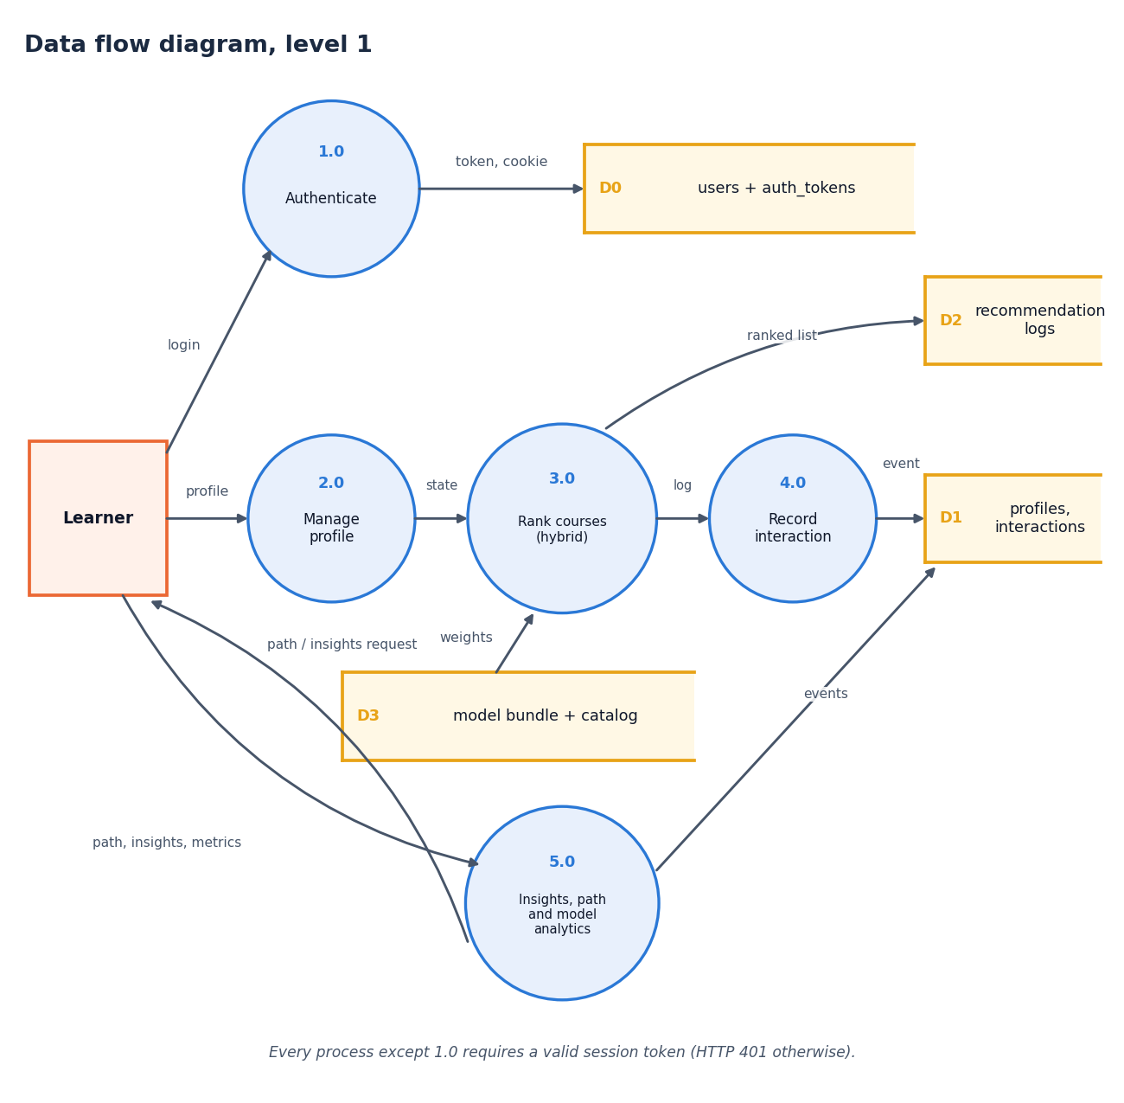
Figure 4: Data flow diagram, level 1
Level 1 has five processes. Authenticate (1.0) checks credentials against the users and tokens store (D0) and issues the token and cookie. Manage profile (2.0) accepts the profile and passes the learner state on to Rank courses (3.0), which reads the model bundle and catalogue (D3) and writes the ranked list to the recommendation log (D2). Record interaction (4.0) writes each event to the profiles and interactions store (D1), and the log from 3.0 feeds it. Insights, path and model analytics (5.0) reads the stored events and returns the learning path, the insights and the model metrics. Every process except 1.0 requires a valid session token and answers HTTP 401 otherwise (the public catalogue and model-analytics routes are the exceptions described in Section 5.7).

Level 2
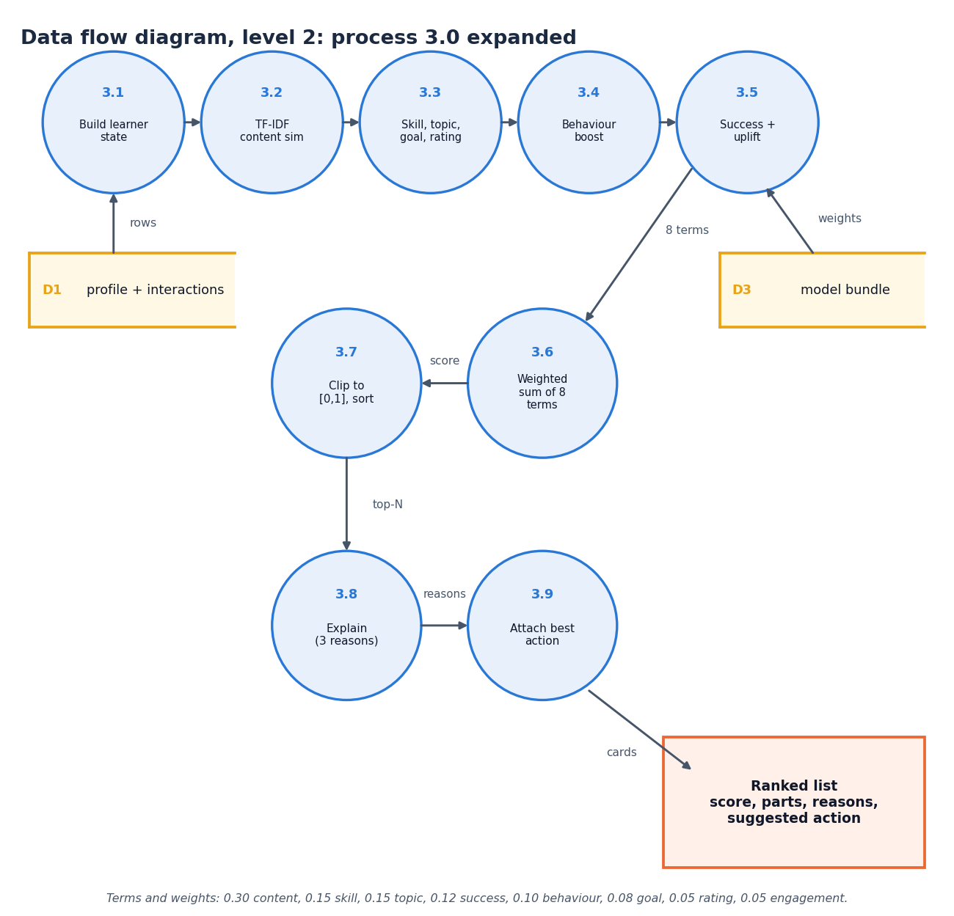
Figure 5: Data flow diagram, level 2: process 3.0 expanded
Level 2 expands the ranking process into nine steps. The learner state is built from the profile and the stored interactions (3.1); the TF-IDF content similarity of the profile against each course text is computed (3.2); the skill-compatibility, topic-interest, goal and rating terms follow (3.3) together with the behavioural boost from earlier events (3.4); the success probability and the per-action uplift come from the model bundle (3.5). The eight terms are combined by a weighted sum (3.6), clipped to [0, 1] and sorted (3.7), up to three reasons are attached to each course (3.8) and the best action (the action with the largest estimated benefit) is attached to every card (3.9). The weights are 0.30, 0.15, 0.15, 0.12, 0.10, 0.08, 0.05 and 0.05.

5.4 UML diagrams

Class diagram
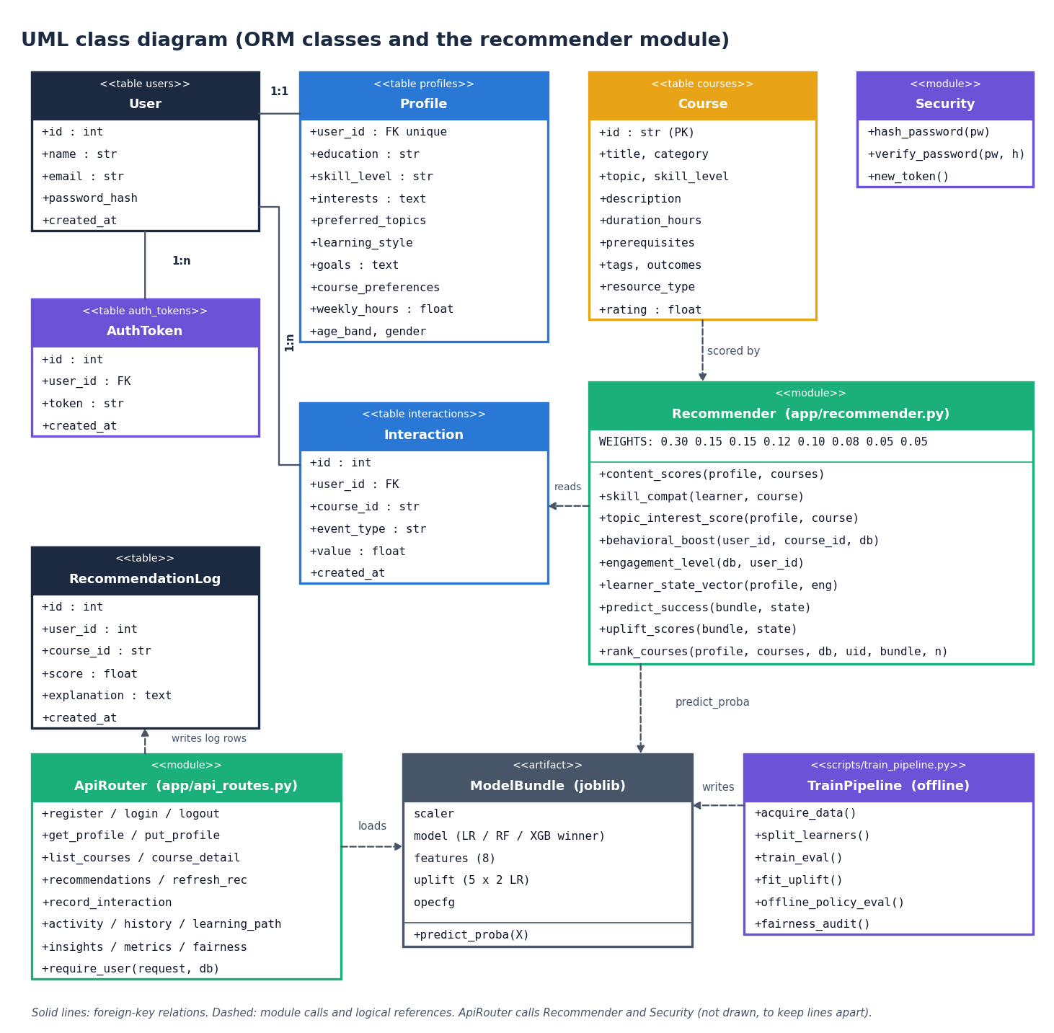
Figure 6: UML class diagram (ORM classes and the recommender module)
The six database tables are mapped by SQLAlchemy classes: User has one Profile and many AuthToken and Interaction rows; Course and RecommendationLog are standalone (the log stores the user and course ids as plain columns). The Recommender module (app/recommender.py) is drawn as a class stereotyped as a module, listing its public functions and the weight vector; it reads Interaction rows, scores Course rows and calls the ModelBundle (the joblib artefact: scaler, selected model, feature list, one-vs-rest uplift models and the policy-evaluation configuration) through predict_proba. ApiRouter (app/api_routes.py) loads the bundle, writes the log rows and uses Security for hashing and tokens; TrainPipeline (scripts/train_pipeline.py) runs offline and writes the bundle. The code base is function-oriented, so modules stand in for classes except in the ORM layer.

Sequence diagram
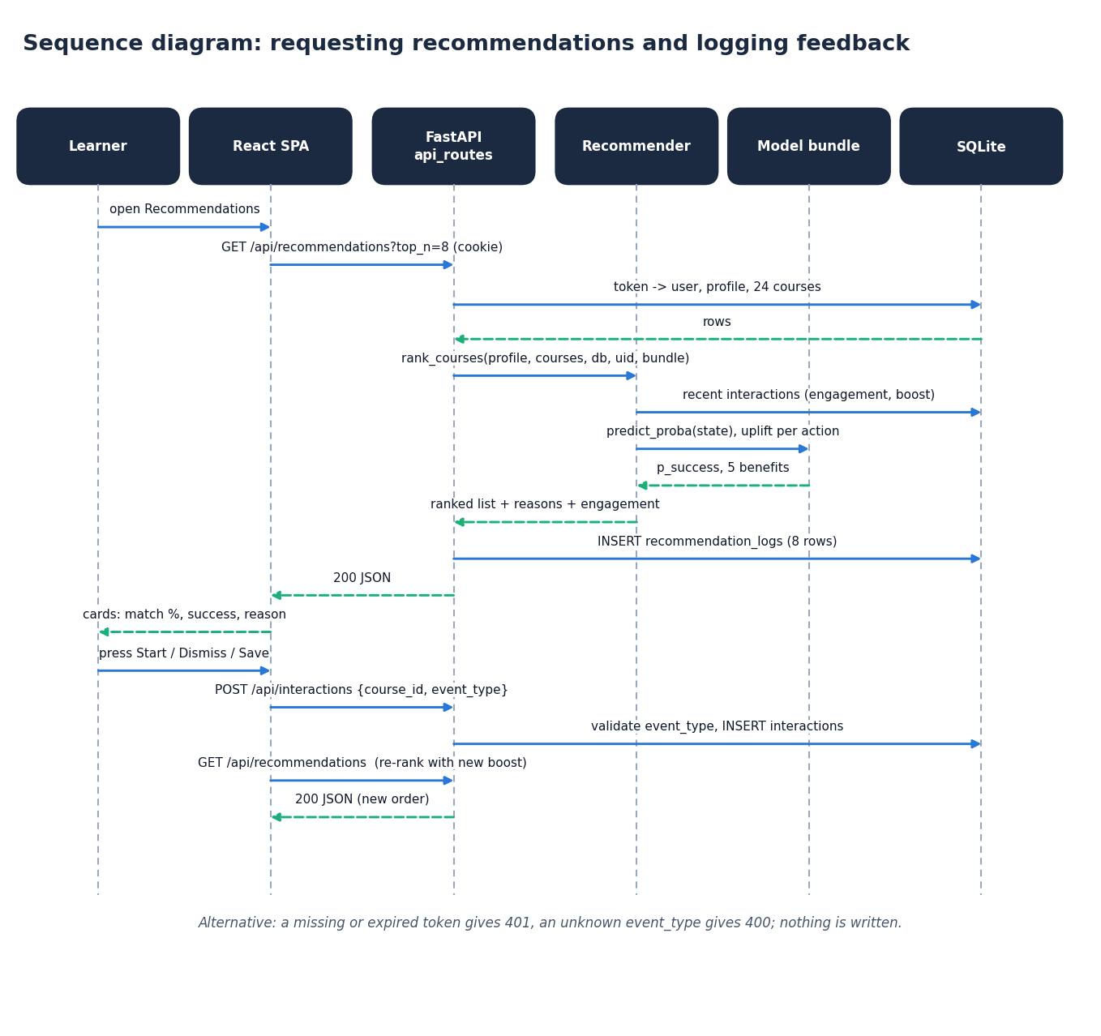
Figure 7: Sequence diagram: requesting recommendations and logging feedback
The sequence follows one pass of the feedback loop. Opening the Recommendations page makes the React app call GET /api/recommendations?top_n=8 with the session cookie. The API resolves the token to a user and loads the profile and the 24 courses from SQLite, then calls rank_courses(). The recommender reads the learner's recent interactions (engagement and boost), asks the model bundle for the success probability and the five action benefits, and returns the ranked list with reasons. The API stores one recommendation_logs row per card and returns the JSON; the page shows the cards. When the learner presses Start, Dismiss or Save, the page posts {course_id, event_type} to /api/interactions; the API validates the event type and inserts the row, and the next GET /api/recommendations returns a list ranked with the new behaviour boost. A missing token gives 401 and an unknown event type gives 400, and nothing is written.

Use-case diagram
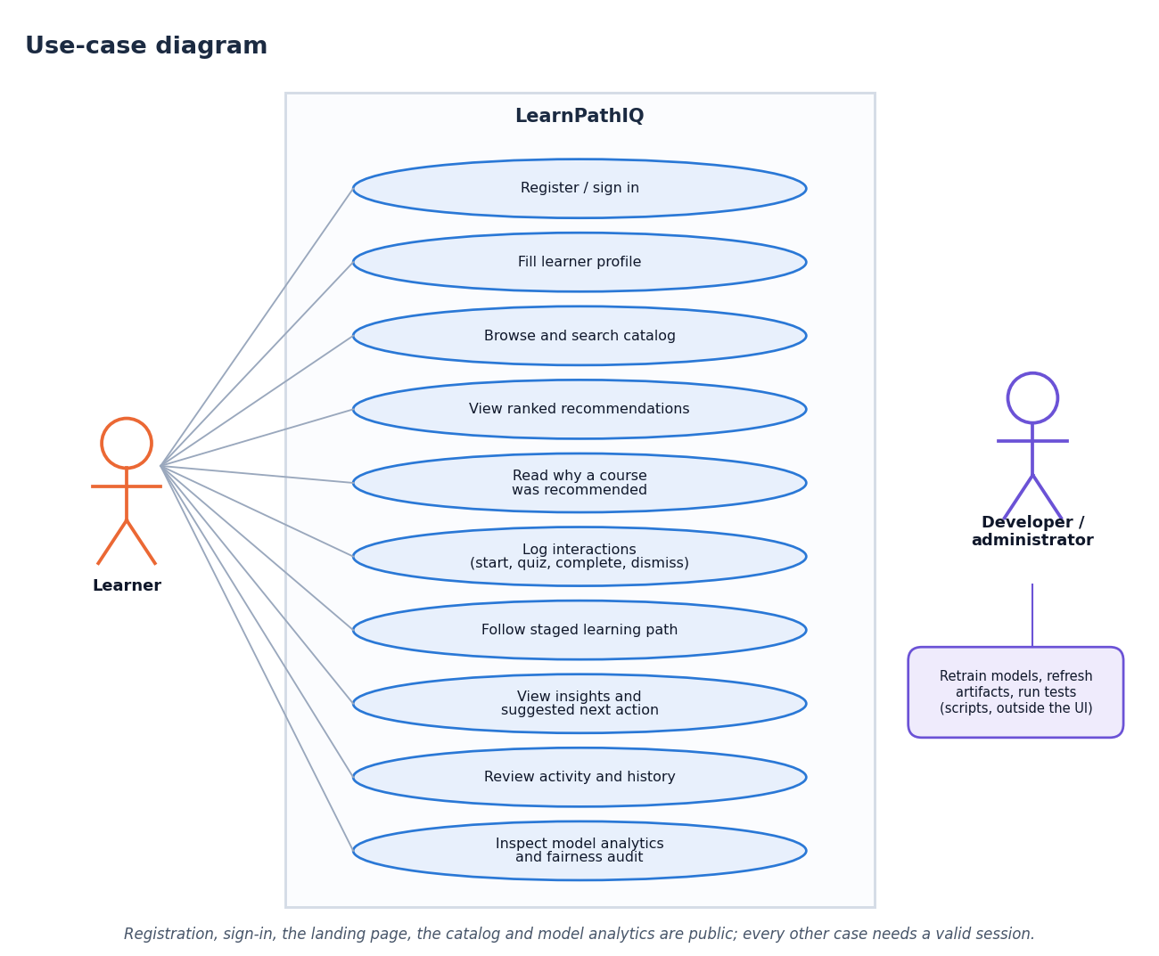
Figure 8: Use-case diagram
The learner can register or sign in, fill the profile, browse and search the catalogue, view ranked recommendations and the reasons for each, log interactions (start, quiz, complete, dismiss and so on), follow the staged learning path, read insights and the suggested next action, review the activity log and recommendation history, and inspect the model analytics and fairness audit. The catalogue, the course detail and the analytics routes are public in the code; the profile, recommendation, path, insight, activity and interaction routes require a session. The developer or administrator is a second actor who retrains the models, refreshes the artefacts and runs the tests with scripts outside the web interface.

Core algorithm flowchart
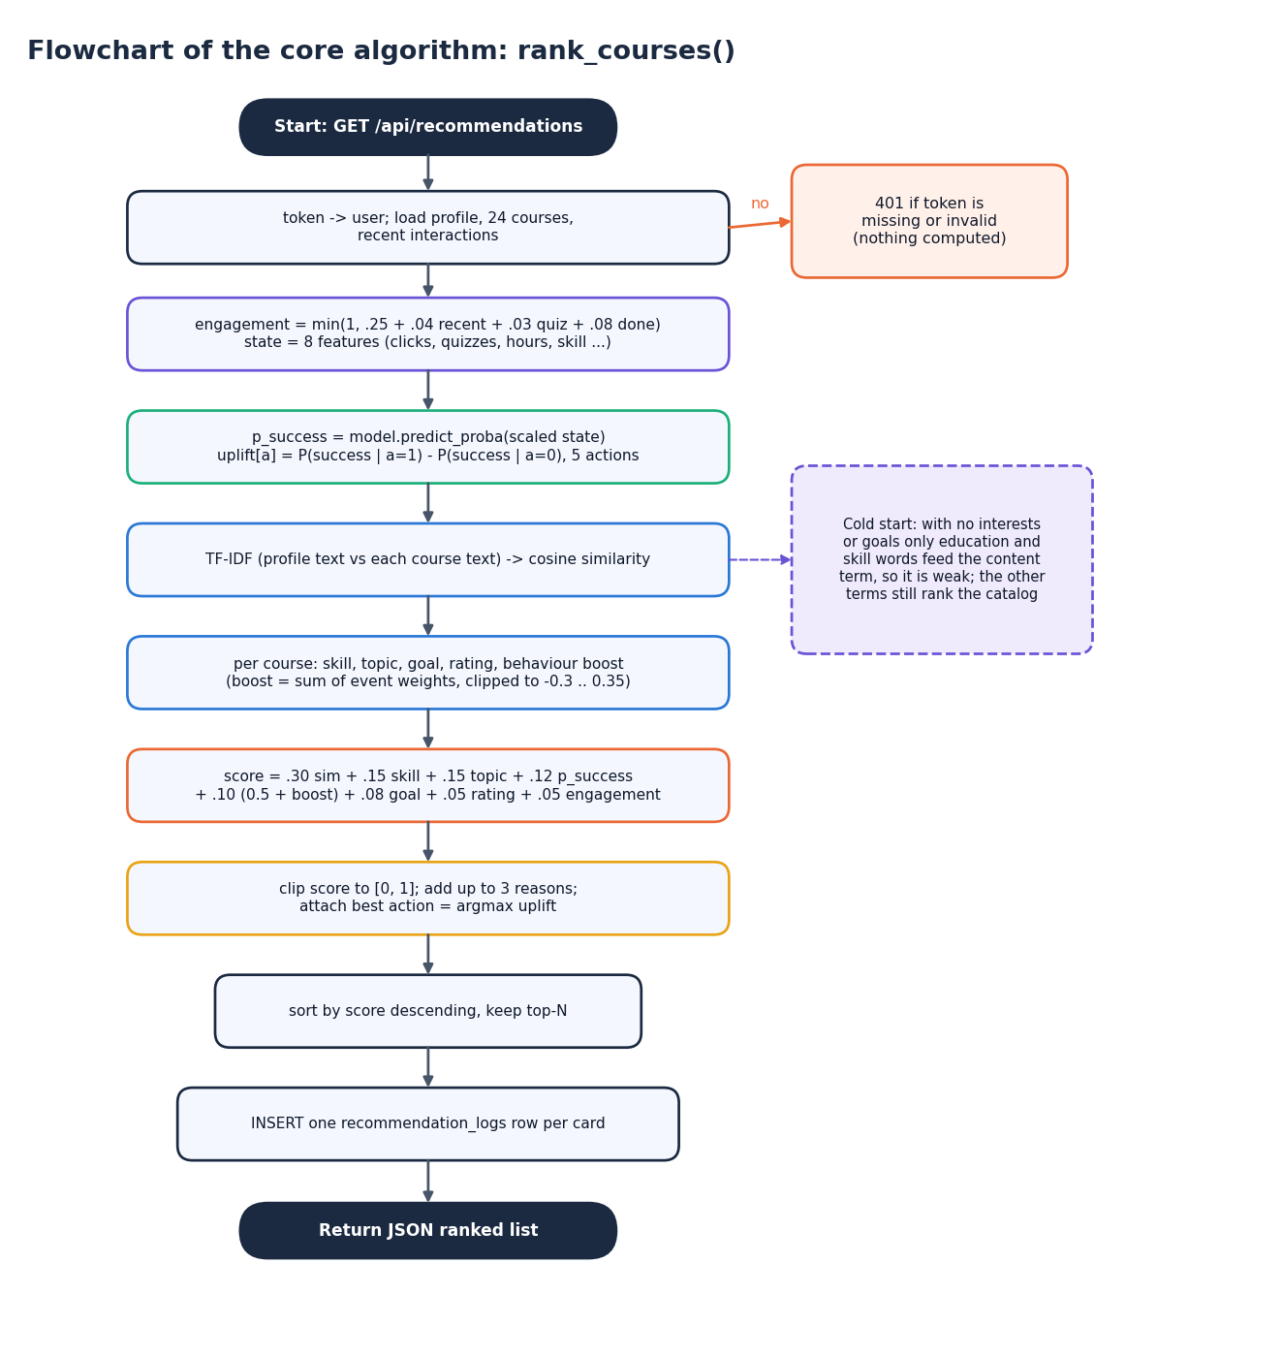
Figure 9: Flowchart of the core algorithm: rank_courses()
The flowchart gives the steps of GET /api/recommendations in order. A missing or invalid token ends the request with 401. Otherwise the profile, the 24 courses and the recent interactions are loaded; the engagement score and the eight-feature learner state are built; the success probability and the per-action uplift are computed; the TF-IDF cosine similarity is computed once for all courses; and for each course the skill, topic, goal, rating and behaviour terms are added to form the weighted score, which is clipped to [0, 1]. Up to three reasons and the best action are attached, the list is sorted and cut to the top N, and one recommendation_logs row is inserted per card before the JSON is returned. With no interests or goals the content term is weak (only the education and skill words feed it) but the other terms still rank the catalogue.

5.5 Database design
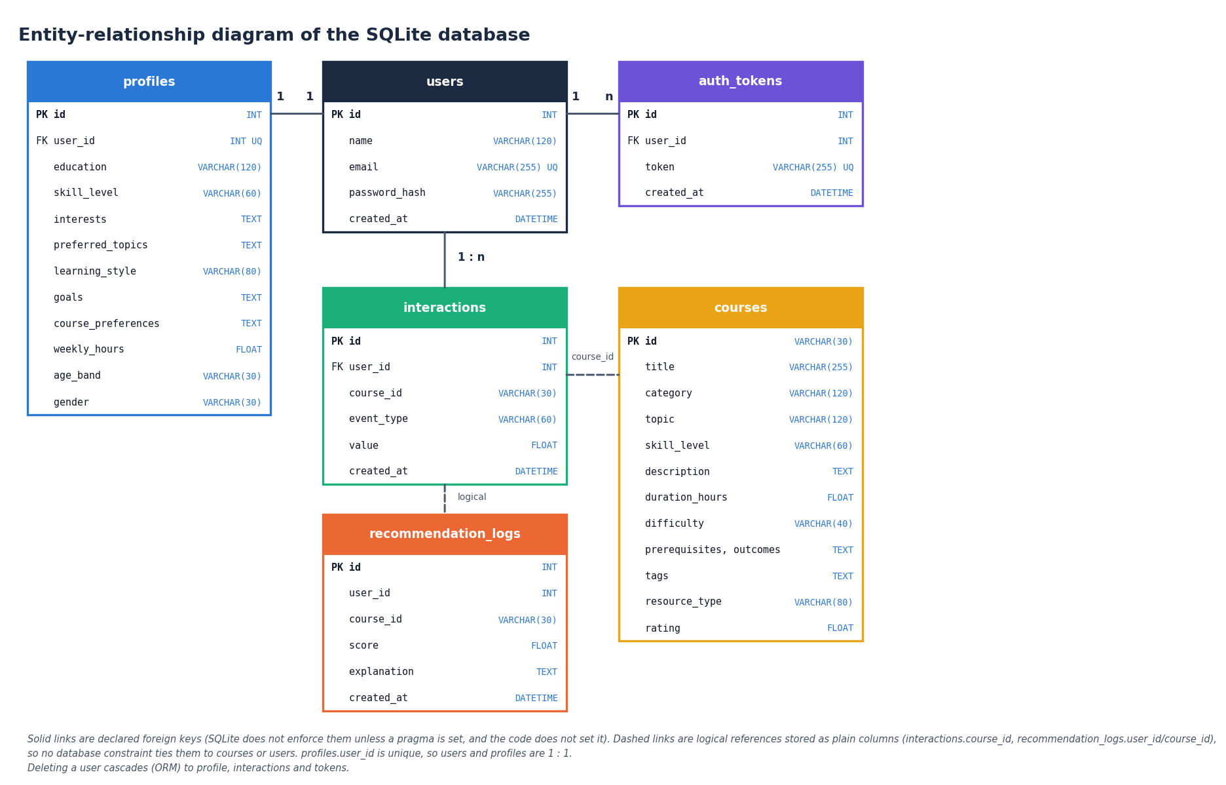
Figure 10: Entity-relationship diagram of the SQLite database
The database has six tables. users is the parent of profiles (one to one, because profiles.user_id is unique), auth_tokens (one to many) and interactions (one to many); these three links are declared foreign keys, and the ORM relationships cascade deletion from a user to its profile, interactions and tokens. courses is referenced by interactions.course_id and recommendation_logs.course_id, and recommendation_logs.user_id refers to a user, but these are plain columns without a declared foreign key, so no database constraint ties them to their parent. SQLite does not enforce declared foreign keys unless a pragma is switched on, and the code does not switch it on.
Table 3: Tables of the SQLite database
Table | Columns | Purpose
users | id (PK), name, email (unique), password_hash, created_at | Learner account; the password is stored only as a PBKDF2-SHA256 hash
profiles | id (PK), user_id (FK, unique), education, skill_level, interests, preferred_topics, learning_style, goals, course_preferences, weekly_hours, age_band, gender, updated_at | One profile per learner; interests and goals are comma-separated text
courses | id (PK, e.g. PY101), title, category, topic, skill_level, description, duration_hours, difficulty, prerequisites, outcomes, tags, resource_type, rating | The 24 seeded courses
interactions | id (PK), user_id (FK), course_id, event_type, value, created_at | Feedback events: view, open, start, content, quiz, forum, save, complete, dismiss
recommendation_logs | id (PK), user_id, course_id, score, explanation, created_at | One row per recommended card, shown on the Activity page
auth_tokens | id (PK), user_id (FK), token (unique), created_at | Opaque session tokens issued at register and login, deleted at logout

The tables are created by init_db() through Base.metadata.create_all, so a fresh checkout needs no migration, and the course table is filled from data/catalog/courses.json the first time the application starts with an empty table. All queries go through the SQLAlchemy ORM, which uses bound parameters, so file names, e-mail addresses and search text are never concatenated into SQL.

5.6 Module design
Table 4: Modules and responsibilities
Module | Responsibility | Key contents
app/main.py | Application entry | creates the FastAPI app, seed_courses(), static mount, Jinja pages /, /register, /login, /onboarding, /dashboard, /recommendations, /course/{id}, /path, /activity, /insights, /analytics
app/api_routes.py | JSON API | 18 routes, get_current_user, require_user, profile_dict, course_dict, cached bundle()
app/recommender.py | Recommendation engine | content_scores, skill_compat, topic_interest_score, behavioral_boost, engagement_level, learner_state_vector, predict_success, uplift_scores, rank_courses, load_ml_bundle
app/models.py, app/database.py | Persistence | six SQLAlchemy classes, engine, SessionLocal, get_db, init_db
app/security.py, app/schemas.py | Security and validation | hash_password, verify_password, new_token; RegisterIn, LoginIn, ProfileIn, InteractionIn
app/config.py | Settings | database URL, secret key, model and artefact folders, read from .env
scripts/train_pipeline.py | Offline training | acquire_data, split_learners, train_eval (models, uplift, policy evaluation, fairness audit, plots)
scripts/run_experiments.py and others | Evidence for the documents | six-seed study, ceiling check, persona evaluation with ablation, feedback-loop probe; measure_api.py, collect_env.py
frontend/src/pages/* | React screens | Landing, Login, Register, Catalog, CourseDetail, Analytics, Dashboard, Recommendations, LearningPath, Insights, Activity, Profile, NotFound
frontend/src/components, lib, styles | UI kit and client logic | layout shells, cards, charts, forms, toasts; api.js, auth.jsx, theme.jsx, useApi.js; design tokens and global CSS
tests/test_app.py, scripts/* | Verification | 5 pytest tests, smoke test, responsive check, screenshot capture

The backend package app/ is 649 lines of Python in total; rank_courses() is the only function the routes need for a ranking and every term it adds comes from a separate helper function.

5.7 API design
The API is JSON over HTTP. Errors use the standard FastAPI body {"detail": "message"}: 400 for a bad event type, a duplicate e-mail or mismatched passwords, 401 for a missing or invalid token or a wrong password, 404 for an unknown course, 422 for a request body that fails Pydantic validation (for example a malformed e-mail address or a name shorter than two characters) and 503 when the training artefacts are missing. The session is a random opaque token (secrets.token_urlsafe(32)) stored in auth_tokens; it is accepted from the HttpOnly cookie lpq_token, the X-Token header or a Bearer header. The catalogue, the course detail, the model metrics and the fairness audit are public by design, because they contain no learner data.
Table 5: REST endpoints
Method | Path | Session | Purpose
POST | /api/auth/register | No | Create account, empty profile and token; sets the cookie
POST | /api/auth/login | No | Verify the password hash; issue a token and cookie
POST | /api/auth/logout | No | Delete the token row and the cookie
GET | /api/me | No | Signed-in user or null
GET / PUT | /api/profile | Yes | Read or update the learner profile
GET | /api/courses?q=&category=&level= | No | Search and filter the catalogue
GET | /api/courses/{id} | No | Course detail; match score, success probability and suggested action when signed in; 404 if unknown
GET | /api/recommendations?top_n= | Yes | Ranked list with the eight term values, reasons, engagement and uplift
POST | /api/recommendations/refresh | Yes | Reload the model bundle and re-rank
POST | /api/interactions | Yes | Log an event; 400 for an unknown event type
GET | /api/activity?limit= | Yes | The learner's latest interaction events
GET | /api/history | Yes | The latest 40 recommendation-log rows
GET | /api/learning-path | Yes | Up to six staged steps and the next best action
GET | /api/insights | Yes | Engagement, success estimate, action benefits, strengths, attention points
GET | /api/metrics | No | Model comparison, confusion matrices, policy evaluation, fairness; 503 if not trained
GET | /api/fairness | No | The fairness audit with a note that it is an audit only
GET | /api/health | No | ok, models_ready, application name
GET | /static/{roc_curve, confusion_matrix, feature_importance}.png | No | The three training plots

The original Jinja2 pages are /, /register, /login, /onboarding, /dashboard, /recommendations, /course/{id}, /path, /activity, /insights and /analytics; each loads its data from the same JSON routes.

5.8 User interface design
The React interface uses a "neo-brutalist grid" visual language: a warm paper background, thick black outlines, hard offset shadows, a visible grid, a heavy display typeface for headings, a sans-serif body face and a monospace face for numbers (fonts from the Fontsource packages). Lime, coral, sky and amber accents carry meaning (for example, lime marks the best next action), and every status is also given as text so that meaning never depends on colour alone. There is a light and a dark theme with a toggle that remembers the choice. The signed-in shell has a sidebar that becomes a drawer on narrow screens, and the public shell has its own header; pages are loaded lazily and show skeleton placeholders while data arrive.
Table 6: Screens
Screen | Content
Landing / | Public introduction with the value proposition, how it works and live catalogue figures
Sign in /login, Register /register | Forms with inline validation messages; a new account is taken to the profile form
Course catalogue /courses | Search and filter by category and level; public, and also available inside the signed-in shell
Course detail /courses/:id | Description, prerequisites, outcomes, tags, the "why recommended" panel, and buttons that log start, content, quiz, discussion and complete events
Model analytics /analytics | Four tabs: model comparison, diagnostics (confusion matrices, ROC curve, feature importance), offline policy evaluation and fairness audit
Dashboard /app | Engagement status, success estimate, next action, recent activity and top recommendations
Recommendations /app/recommendations | Ranked cards with match percentage, success estimate, suggested action and explanation; search, refresh, view, start, dismiss
Learning path /app/path | Up to six staged steps with the reason and action for each, and the next best action
Insights /app/insights | Engagement, success estimate, estimated benefit by action, strengths and attention points, interactions by type
Activity /app/activity | Interaction log and recommendation history
Profile /app/profile | The learner profile form, also shown first after registration
Not found * | A 404 page with a way back

Accessibility was designed in rather than added later: a skip link is the first keyboard stop on every page, focus outlines are visible, the mobile drawer is a dialog that closes with the Escape key, and a reduced-motion setting collapses animation to fades. Chapter 7 reports the automated check of the layout at three widths in both themes.

2. IMPLEMENTATION

6.9 Technology stack
Table 7: Backend and tooling (versions measured in the project environment)
Component | Version | Role
Python | 3.11.9 | Language of the backend and the training script
FastAPI [21] | 0.115.6 | Web framework and OpenAPI generation
Uvicorn | 0.34.0 | ASGI server
SQLAlchemy [22] | 2.0.36 | ORM over the SQLite file
Pydantic | 2.10.4 | Request validation (including e-mail check)
scikit-learn [13] | 1.5.2 | TF-IDF, logistic regression, random forest, metrics
XGBoost [12] | 2.1.3 | Gradient-boosted trees (one of the three candidates)
pandas / NumPy | 2.2.3 / 1.26.4 | Data table and arrays
joblib | 1.4.2 | Saving and loading the models
Matplotlib | 3.9.2 | Training plots and the documentation figures
Passlib | 1.7.4 | PBKDF2-SHA256 password hashing
pytest | 8.3.4 | Automated tests
Node.js / npm | v24.19.0 / 11.17.0 | Frontend build and development server

Table 8: Frontend dependencies declared in frontend/package.json
Package | Version | Role
react, react-dom | ^19.3.1 | User interface
react-router-dom | ^7.18.4 | Routing with lazy-loaded pages
recharts | ^3.10.1 | Bar charts of benefits, interactions and model metrics
vite, @vitejs/plugin-react | ^8.3.5, ^6.1.2 | Development server with proxy, production build
framer-motion, gsap, lenis | ^14.5.0, ^3.15.0, ^1.3.27 | Page transitions and motion
lucide-react | ^1.61.0 | Icons
@fontsource/* (Archivo Black, IBM Plex Sans, IBM Plex Mono) | ^5.3.0 | Self-hosted fonts

requirements.txt pins every Python package, including Jinja2 3.1.4, python-multipart, email-validator, requests, Pillow and Playwright 1.49.1, so the environment can be rebuilt. The machine used is a 12th-generation Intel Core i5-12500 (6 cores, 12 threads) with 15.7 GB of memory and no GPU, running Windows 11.

6.10 Backend implementation
app/main.py creates the FastAPI application, calls init_db(), fills the courses table from data/catalog/courses.json if it is empty, mounts /static and includes the router of app/api_routes.py. The routes are thin: each resolves the learner with require_user(), loads the profile and the 24 courses, calls into app/recommender.py and returns a dictionary. The model bundle is loaded lazily on first use by bundle() and cached in a module variable; POST /api/recommendations/refresh reloads it. rank_courses() is used by the recommendations route, by the learning-path route (top 12, then re-ordered) and by the course-detail route (top 50, to find the course's own score and reasons), and every recommendations call writes one recommendation_logs row per returned card.
def rank_courses(profile, courses, db, user_id, bundle, top_n=8):
sims = content_scores(profile, courses)
eng = engagement_level(db, user_id)
state = learner_state_vector(profile, eng)
p_success, feat_imp = predict_success(bundle, state)
upl = uplift_scores(bundle, state)
ranked = []
for i, c in enumerate(courses):
cs = float(sims[i]) if len(sims) > i else 0.0
sk = skill_compat(profile.get("skill_level", "Beginner"), c.get("skill_level", "Beginner"))
ti = topic_interest_score(profile, c)
beh = behavioral_boost(user_id, c.get("id", ""), db)
...
score = 0.30*cs + 0.15*sk + 0.15*ti + 0.12*p_success + 0.10*(0.5+beh) + 0.08*goal + 0.05*rating_f + 0.05*eng["score"]
score = round(float(max(0, min(1, score))), 4)
...
ranked.sort(key=lambda x: x["score"], reverse=True)
return ranked[:top_n], {"engagement": eng, "p_success": ..., "uplift": upl, ...}

The catalogue is small and hand-written (24 courses in nine categories, from Data Science with six courses to Design with one, rated 4.3 to 4.7 and lasting 4 to 30 hours), so everything is computed per request without a cache or an index; Chapter 7 gives the measured latency.

6.11 Training script and saved artefacts
python scripts/train_pipeline.py runs acquire_data(), split_learners() and train_eval() and writes: data/processed/learner_states.csv (the synthetic table); models/scaler.joblib, models/xgb_model.joblib (the selected model), models/feature_cols.joblib, models/all_models.joblib (all three models; it is large and git-ignored, and is never read at run time), models/uplift.joblib and models/ope.joblib; artifacts/metrics/model_metrics.json (metrics, confusion matrices, feature importance, policy evaluation, fairness); and three plots in artifacts/plots/, which are copied to app/static/ so that the analytics page can show them. run.bat trains automatically when the metrics file is missing.
A defect found while preparing the frontend shows why the artefacts must match the pinned library versions: files saved with a newer scikit-learn could not be used under scikit-learn 1.5.2, and because predict_success() and uplift_scores() catch every exception, the application silently fell back to a constant 55 % success estimate and zero action benefits. Re-running the unchanged script under the pinned versions fixed it (selected model and test AUC were unchanged). The silent fallback is deliberate so the pages never crash, but it hides this kind of fault; the smoke test now checks that the success estimate differs from 0.55.

6.12 Frontend implementation
The React application (frontend/src) has App.jsx with three layouts: public pages (landing, sign in, register), adaptive pages that use the signed-in or the public shell (catalogue, course detail, model analytics) and the protected /app area guarded by RequireAuth, which redirects to the sign-in page. Pages are loaded with React.lazy, so the chart library stays in its own chunks. lib/api.js wraps fetch with credentials: same-origin, turns FastAPI's string or list detail into one readable message and fires an event on a 401 so the session can be cleared; useApi runs a loader on mount, ignores stale responses and exposes {data, error, loading, reload}; lib/auth.jsx keeps the user from GET /api/me; lib/theme.jsx stores the light or dark choice. Shared components (cards, stat tiles, charts, forms, tables, toasts, skeletons) live in components/ui, and the design tokens (colours, fonts, borders, shadows, spacing) in styles/tokens.css. The Vite server proxies /api and /static to port 8407, so the HttpOnly cookie is never exposed to scripts and no cross-origin configuration is needed.

6.13 Security and error handling
Table 9: Controls
Threat or fault | Control in the code
Password theft from the database | Passwords are stored only as PBKDF2-SHA256 hashes (29,000 rounds, Passlib); the password is cut to 72 bytes before hashing
Unauthenticated access | Profile, recommendation, path, insight, activity and interaction routes depend on require_user() and answer 401
Token guessing | Tokens are secrets.token_urlsafe(32) values stored in auth_tokens; logout deletes the row
Script access to the session | Cookie lpq_token is HttpOnly and SameSite=Lax with a 72-hour lifetime
Malformed input | Pydantic: name 2-120 characters, e-mail format, password 6-100 characters; unknown event types answered with 400
SQL injection | All data access goes through the ORM with bound parameters
Missing or unusable model | The ranker falls back to a 0.55 success estimate and heuristic action scores; GET /api/health reports models_ready; /api/metrics answers 503

Known weaknesses: the tokens have no server-side expiry (the token_expire_hours and secret_key settings exist in app/config.py but no code uses them), a token is also accepted from a request header, each login adds a new token row, there is no rate limiting or password-reset flow, the transport is plain HTTP on localhost and the session is demonstration-grade. The application is intended for local use.

6.14 Installation and execution
run.bat reads the ports from .env (backend 8407, frontend 5407), creates a .venv if needed, installs requirements.txt, trains the models if the metrics file is missing, runs npm install in frontend/ on first use, starts the API (python -m uvicorn app.main:app) and the Vite server in two windows and opens the browser; the original server-rendered interface stays available on port 8407. A Dockerfile and docker-compose.yml are present in the project folder but were not run for these documents. Appendix B gives the full guide.

3. KEY CODE WALK-THROUGHS

3.1 The hybrid score
rank_courses computes one learner-level context (engagement, success probability, estimated action benefits) and then scores every course with eight terms. The weights sum to 1.00 and the result is clipped to [0, 1], rounded and sorted. The same function serves /api/recommendations and /api/learning-path.
def rank_courses(profile, courses, db, user_id, bundle, top_n=8):
sims = content_scores(profile, courses)
eng = engagement_level(db, user_id)
state = learner_state_vector(profile, eng)
p_success, feat_imp = predict_success(bundle, state)
upl = uplift_scores(bundle, state)
ranked = []
for i, c in enumerate(courses):
cs = float(sims[i]) if len(sims) > i else 0.0
sk = skill_compat(profile.get("skill_level","Beginner"), c.get("skill_level","Beginner"))
ti = topic_interest_score(profile, c)
beh = behavioral_boost(user_id, c.get("id",""), db)
goal = 0.7 if any(g.strip().lower() in (c.get("title","")+c.get("description","")+c.get("tags","")).lower() for g in (profile.get("goals","").split(",") if profile.get("goals") else []) if g.strip()) else 0.4
rating_f = (float(c.get("rating", 4.5)) - 3.5) / 1.5
rating_f = max(0, min(1, rating_f))
score = 0.30*cs + 0.15*sk + 0.15*ti + 0.12*p_success + 0.10*(0.5+beh) + 0.08*goal + 0.05*rating_f + 0.05*eng["score"]
score = round(float(max(0, min(1, score))), 4)

reasons = []
if cs > 0.08: reasons.append(f"Matches your interests ({', '.join((c.get('tags','').split(',')[:2]))})")
elif ti > 0.3: reasons.append(f"Aligned with your topic preferences in {c.get('topic','')}")
else: reasons.append(f"Broadens your {c.get('category','')} knowledge")
if sk >= 0.9: reasons.append("Fits your current skill level")
elif sk < 0.6: reasons.append("Stretches you slightly beyond your level" if SKILL_ORDER.get(c.get('skill_level','Beginner'),0) > SKILL_ORDER.get(profile.get('skill_level','Beginner'),0) else "A comfortable refresher for your level")
if beh > 0.05: reasons.append("You have engaged with similar material before")
if p_success > 0.6: reasons.append(f"High estimated completion likelihood ({p_success:.0%})")
best_act = max(upl, key=lambda k: upl[k]) if upl else "continue_course"
est_benefit = round(float(upl.get(best_act, 0.0)), 4)
ranked.append({"course": c, "score": score, "content_sim": round(float(cs),4),
"skill_compat": round(float(sk),3), "topic_fit": round(float(ti),3),
"success_prob": round(float(p_success),4), "behavior": round(float(beh),4),
"est_benefit": est_benefit, "suggested_action": best_act,
"suggested_action_label": ACTION_LABEL.get(best_act, best_act),
"explanation": "; ".join(reasons[:3])})

3.2 Behaviour and engagement
Interaction events change the next ranking through two functions. The behavioural boost adds a signed weight for each event on the same course, clipped to [-0.3, 0.35]; a dismissal costs -0.25. The engagement score is built from the learner's recent events, quizzes and completions and doubles as one of the eight success-model features.
def behavioral_boost(user_id: int, course_id: str, db) -> float:
from app.models import Interaction
rows = db.query(Interaction).filter(Interaction.user_id == user_id).all()
if not rows:
return 0.0
w = {"view": 0.05, "open": 0.06, "start": 0.12, "content": 0.10, "quiz": 0.14, "forum": 0.10, "save": 0.08, "complete": 0.20, "dismiss": -0.25}
s = 0.0
for r in rows:
if r.course_id == course_id:
s += w.get(r.event_type, 0.03) * (r.value or 1.0)
return max(-0.3, min(0.35, s))

def engagement_level(db, user_id: int) -> Dict[str, Any]:
from app.models import Interaction
from datetime import datetime, timedelta
rows = db.query(Interaction).filter(Interaction.user_id == user_id).order_by(Interaction.created_at.desc()).limit(200).all()
total = len(rows)
recent = sum(1 for r in rows if r.event_type in ("view","open","start","content","quiz","forum"))
quizzes = sum(1 for r in rows if r.event_type == "quiz")
forums = sum(1 for r in rows if r.event_type == "forum")
completes = sum(1 for r in rows if r.event_type == "complete")
if total == 0:
return {"label": "Getting started", "score": 0.25, "total": 0, "quizzes": 0, "forums": 0, "completes": 0}
score = min(1.0, 0.25 + recent * 0.04 + quizzes * 0.03 + completes * 0.08)
label = "Getting started" if score < 0.4 else ("Steady learner" if score < 0.7 else "Highly engaged")
if any(r.event_type == "dismiss" for r in rows[:5]) and score < 0.45:
label = "Needs a nudge"
return {"label": label, "score": round(float(score),3), "total": total, "quizzes": quizzes, "forums": forums, "completes": completes}

3.3 Success estimate and action benefit
The success model is the validation-AUC winner saved by the training script. The action benefit is the difference between two logistic regressions per action (action taken versus not taken); if the model files are missing, a small hand-written heuristic is returned instead so that the page never fails.
for a in actions:
if a in up and isinstance(up[a], dict) and up[a].get("t1") is not None:
p1 = float(up[a]["t1"].predict_proba(Xs)[0][1])
p0 = float(up[a]["t0"].predict_proba(Xs)[0][1])
out[a] = round(p1 - p0, 4)
else:
out[a] = 0.0

3.4 Authentication
Registration hashes the password with PBKDF2-SHA256, stores a random URL-safe token in auth_tokens and sets it as an HttpOnly cookie; the same token is accepted in an X-Token or Bearer header for API clients.
@router.post("/api/auth/register")
def register(body: RegisterIn, response: Response, db: Session = Depends(get_db)):
if body.password != body.confirm_password:
raise HTTPException(400, "Passwords do not match")
if db.query(User).filter(User.email == body.email.lower()).first():
raise HTTPException(400, "Email already registered")
u = User(name=body.name.strip(), email=body.email.lower().strip(), password_hash=hash_password(body.password))
db.add(u); db.commit(); db.refresh(u)
db.add(Profile(user_id=u.id)); db.commit()
t = new_token(); db.add(AuthToken(user_id=u.id, token=t)); db.commit()
response.set_cookie("lpq_token", t, httponly=True, samesite="lax", max_age=72*3600)
return {"ok": True, "token": t, "user": {"id": u.id, "name": u.name, "email": u.email}}

3.5 Offline policy evaluation in the training script
The target policy picks the action with the highest estimated benefit for every test row; the behaviour policy is a multinomial logistic regression over the logged actions. Propensities are clipped, importance weights are capped, and the effective sample size is computed from the weights. The doubly robust value uses the selected success model as its outcome model without an action input, a simplification that is one more reason to read the values as rough.
# propensities
cmap = {c:i for i,c in enumerate(classes)}
pi_b = _np.array([Pbeh[i, cmap.get(a, 0)] if a in cmap else 1e-3 for i, a in enumerate(te["action"].values)])
pi_b = _np.clip(pi_b, 0.02, 0.98) # clipping
match = (tgt_actions == te["action"].values).astype(float)
w = match / pi_b
w = _np.clip(w, 0, 10)
ips = float(_np.mean(w * rewards))
denom = float(_np.mean(w))
snips = float(ips / denom) if denom > 1e-9 else None
# DR with outcome model = selected model
qhat = fitted[selected].predict_proba(Xtes)[:,1]
dr = float(_np.mean(qhat + w * (rewards - qhat)))
ess = float((w.sum()**2) / max((_np.square(w)).sum(), 1e-9))

4. IMPLEMENTATION DECISIONS AND THEIR REASONS
Table 10: Decisions and reasons
Decision | Alternatives considered | Reason | Consequence
FastAPI + SQLAlchemy + SQLite | Django, Flask, PostgreSQL | Typed request validation, automatic docs, one file to back up, no service to run [21], [22] | Single node; not built for many concurrent writers
Keep the Jinja2 UI and add a React front end on a Vite proxy | Replace the original UI; cross-origin API calls | Both screens use the same routes; the proxy keeps one origin so the HttpOnly cookie is first-party | Two interfaces to maintain; a production setup would need a reverse proxy
TF-IDF cosine at request time | Pre-computed embeddings, a vector index, contrastive BERT [2] | Only 24 short course texts; no training data for embeddings; a refit is a few milliseconds | Vocabulary is refitted on every request; no semantic matching beyond shared words
Hand-set score weights | Learn the weights (learning to rank) | No relevance labels from real learners to learn from; fixed weights are easy to explain and ablate | Weights are untuned; the ablation shows two terms that do not help on the persona set
Eight separate terms in one linear score | A single opaque model | Every reason shown to the learner maps to one term | Cannot capture interactions between terms
Success model chosen by validation AUC among LR, RF and XGBoost | Always XGBoost; tune | The base paper uses XGBoost, but here the simplest model is as good on the synthetic data (six seeds) | The choice flips between logistic regression and XGBoost across seeds
One-vs-rest T-learner with logistic regressions | Causal forests, doubly robust learners, an RL agent [9], [18] | Few lines, no extra library, produces a benefit per action | Unstable, extrapolates from a confounded log; presented only as an estimate
Synthetic OULAD-like data | Download real OULAD [4] | The training script only probes the dataset page and does not download it; the project needs a reproducible, licence-free table | Every number describes the generator; stated in the interface and in every document
Recompute recommendations on every request | Cache by learner state | A change in profile or in one event must show at once | 32.8 ms mean per ranked list; fine for one user, untested for many
Learning path = ranked top 12, sorted by level then score, first six kept | Prerequisite graph, knowledge tracing [19], [10] | No reliable prerequisite data; the rule is easy to explain | Prerequisite text is shown but not enforced
PBKDF2-SHA256 hashes and random tokens stored in a table | JWT, OAuth | Revocable by deleting a row (logout), no signing key to manage | No server-side expiry check; local demonstration use only

